
2025 SYDNEY ROYAL FLOWER & GARDEN SHOW
11 April - 22 April 2025

Work Kit

Classes 385 & 568 *Any other items/tools will be removed by stewards.

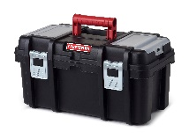 | 1 | Toolbox
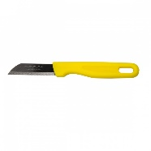 | 1 | Floristry knife
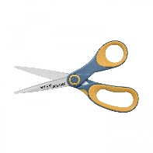 | 1 | Scissors
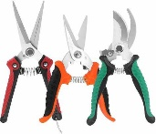 | 1-3 | secateurs/ clippers/ cutters
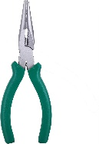 | 1-3 | Pliers
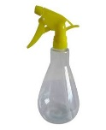 | 1 | Spray bottle
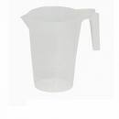  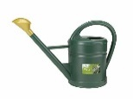 | 1 | Small watering can or plastic jug
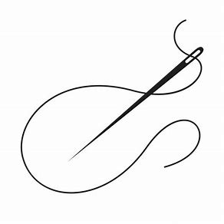 | 1  1 | Sewing needle  Thread black – can be used and left in floral designs and used on fabric
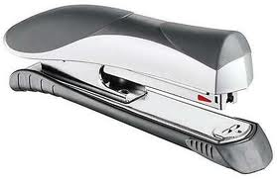 | 1  50 | Stapler  Staples - Can be left in floral designs and used on fabric
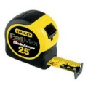   | 1 | Tape measure 5m
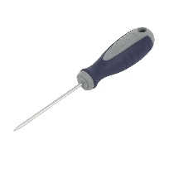 | 1 | Bradawl (hole maker)
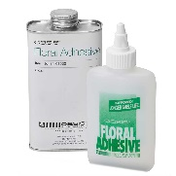 | 1-2 | Cold glue/ floral glue  - Tube/tin allowed
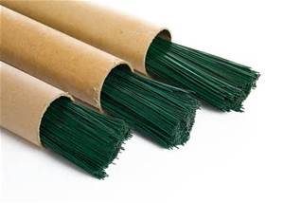 | 1-6 | Variety of wire various gauges  - maximum 1 tube of each gauge allowed  - decorative wire not allowed
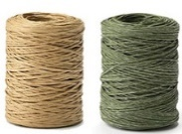 | 1 + 1 | Oasis Bind wire  - 1 roll brown  - 1 roll green
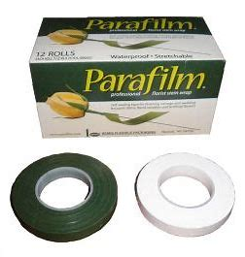 | 1 + 1 | Oasis Parafilm/ floral tape  - 1 roll green  - 1 roll white
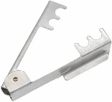 | 1 | Stem stripper
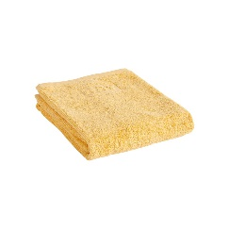 | 1 | Hand towel  - Use for cleaning only
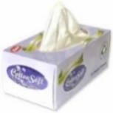   | 1  1 | Leaf wipes/ baby wipes (NOT aerosols)  Tissues  - Use for cleaning only
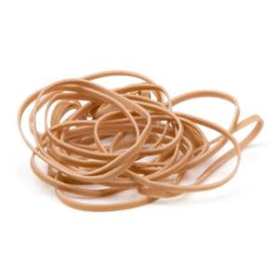 | 20 | Rubber bands  - Various sizes allowed

